Note - these are the Officers & Chairmen for Rotary Year 1st July 2021 to 30th June 2022
President  Chairs both the normal weekly meetings and the monthly council meetings. Ultimately runs everything! | 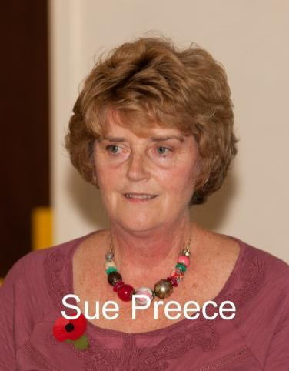 |  | Vice-President  Whoever is elected Vice-President each year automatically becomes President the next. The VP is also responsible for membership development. | 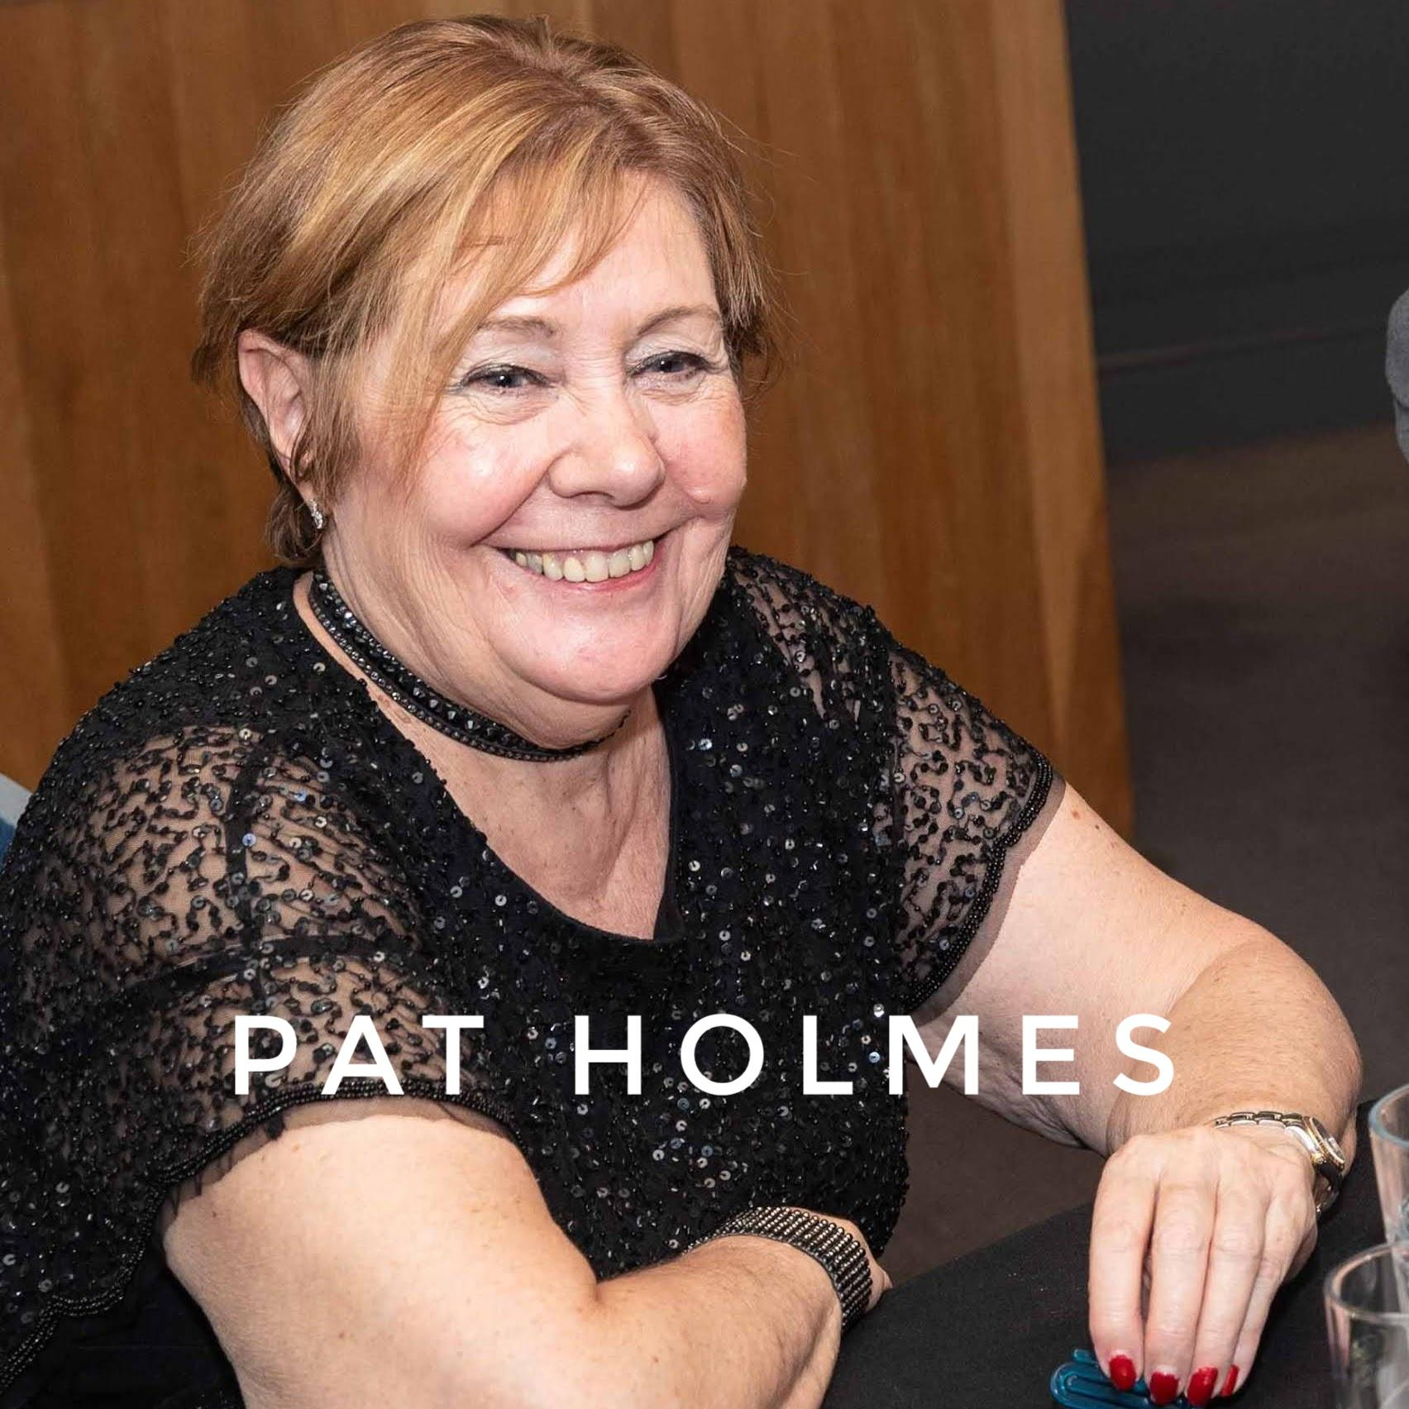
Secretary  The secretary is the recipient of all inbound material from the rest of Rotary (district, UK and international). This has to be forwarded on as appropriate to the relevant members. The secretary is responsible for various club admin procedures, running the AGM's, update of RI membership records etc. | 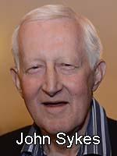 |  | Treasurer  Maintains the accounts, naturally. We have two separate accounts: the house account used for all things to do with running B&WR as a club and the Charity account. This contains all the moneys we collect at various events, before it is presented to the the charities we choose to support. An all too onerous part of the treasurers job is the counting of many thousands of pounds in coins we collect each year ! | 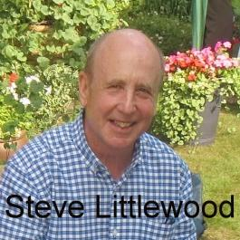
Ways & Means  Responsible for our fund raising. Our two two main collection eventsare the Duck Race in May, and the Christmas collections. Plus other smaller events. This is the largest committee as the organisation of these events requires large amounts of skill and effort. |  |  | Community Service  Co-ordinates our support of the local community. This covers activities we do to help the community directly with our time and effort and allocating the moneys we raise to local charities. | 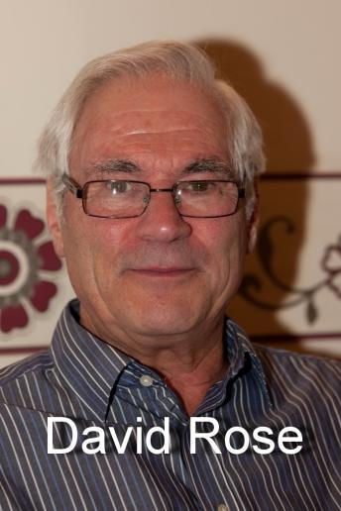
International  Controls our work with international charities, and with the major world charitable concerns RI maintains. Rotary’s own charity, the Rotary Foundation, is also included within this committee. | 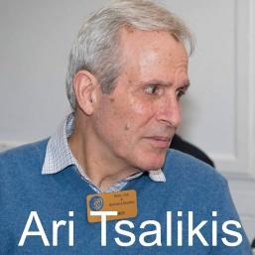 |  | PR & Comm's  Mostly concerned with publicising our charitable work within the local press and on-line etc. | 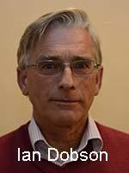
Club Services  Runs the regular weekly meetings. This involves finding speakers or planning other events (done via a rota of members). Collecting the weekly moneys for the meals and maintaining an "attendance" service for guests & members. | 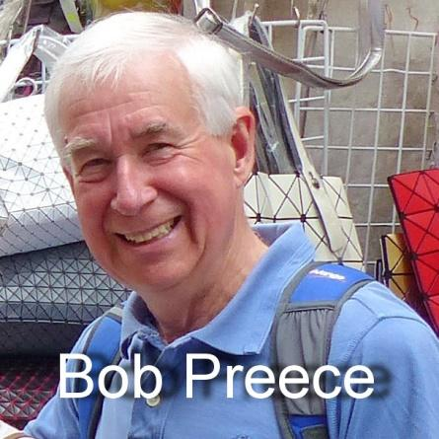 |  | Social  Runs the social functions we have as a club. The main formal ones each year are "President's Night", in March and Charter Night in Sept/Oct. President's drinks in Dec/Jan and a BBQ in Jun/Jul complete the main annual events. There are various other events like theatre trips organised. | 